**Submission Form**

**Fill up the following slots with appropriate content. You must submit the content of this document from this page only.**

1. Your Name: Mohammad Shafkat Hasan
2. Your ID: 19101077
3. Your Section: 04
4. Experiment No: 3
5. Experiment Title: **To verify the value of vacuum permittivity by a parallel plate capacitor.**
6. **You must write your ID in each of the graphs you insert here.**
7. **Data Table 1**:

$$A = 140 mm^{2}$$

|  |  |  |
| --- | --- | --- |
| **Sl:** | **Separation between plates, d (mm)** | **Capacitance, C**  **(pF)** |
| 1. | 2 | 0.62 |
| 2. | 3 | 0.41 |
| 3. | 4 | 0.31 |
| 4 | 5 | 0.25 |
| 5 | 6 | 0.21 |
| 6. | 7 | 0.18 |
| 7. | 8 | 0.15 |
| 8. | 9 | 0.14 |
| 9. | 10 | 0.12 |

**8. Data Table 2:**

$d = 7 mm^{}$

|  |  |  |
| --- | --- | --- |
| **Sl:** | ***Area, A***  ***( $mm^{2}$)*** | **Capacitance, C**  **(pF)** |
| 1. | 100 | 0.13 |
| 2. | 150 | 0.19 |
| 3. | 200 | 0.25 |
| 4 | 250 | 0.32 |
| 5 | 300 | 0.38 |
| 6. | 350 | 0.44 |
| 7. | 400 | 0.51 |

9. Draw C vs 1/d graph for Data Table 1 and, that is, you plot 1/d along the x-axis

and C along the y-axis. You will get a straight line. Find the slope of the line. Insert graph-1 (for A) as image here:

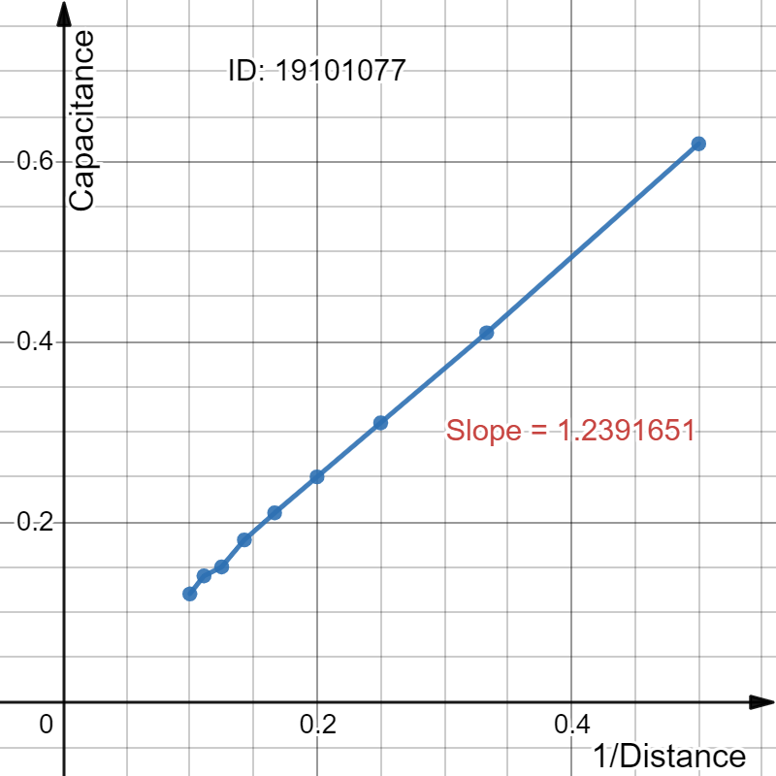

10. Draw C vs A graph for Data Table 2 and, that is you plot A along the x-axis and C along the y-axis. You will get a straight line. Find the slope of the line. Insert **graph-2** (for d) as image here:

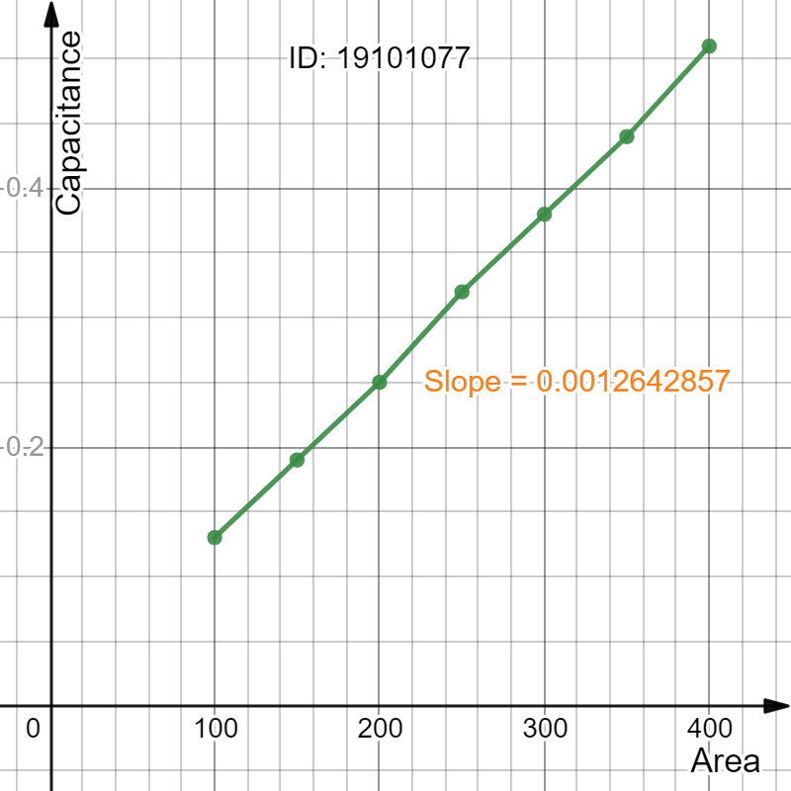

[ Use the formula for capacitance of a parallel plate capacitor to compute vacuum permittivity from slope.]

11. For Data Table 1,

Slope = 1.23917 $\frac{pF}{{mm^{-1}}^{}}$

Calculated value of vacuum permittivity, = (

=

12. For Data Table 2,

Slope = 0.00126429 $\frac{pF}{{mm^{2}}^{}}$

Calculated value of vacuum permittivity, = (

=

13. From the calculated value of vacuum permittivity from 11 & 12, we calculate the mean.

Mean vacuum permittivity = $8.850622143×{10}^{-12}{C^{2}N^{-1}m^{-2}}^{}$.

**Comparing the calculated mean vacuum permittivity with the with the standard value of vacuum permittivity (ε_0 = $8.854 ×10{}^{-12}{C^{2}N^{-1}m^{-2}}^{}$), we calculate the percentage of error.**

Percentage of error = [| Calculated mean vacuum permittivity - Standard vacuum permittivity| /Standard vacuum permittivity] * 100

= 0.0382 %

You are ***strongly*** encouraged to use your **own words** to describe your thoughts for the following part. **However, any kind of plagiarism (such as copying and pasting from other students’ lab-reports) will not be tolerated and will be subject to disciplinary action according to BracU policy.**

Please briefly answer the following question(s):

13. If we place a dielectric material of dielectric constant, κ>1 in place of air in between the plates of a parallel plate capacitor then what should be the change in graph-1 (C vs 1/d graph for Data Table 1)? Explain.

hint: You may sketch a diagram in your answer to help you compare both the cases.

Ans:

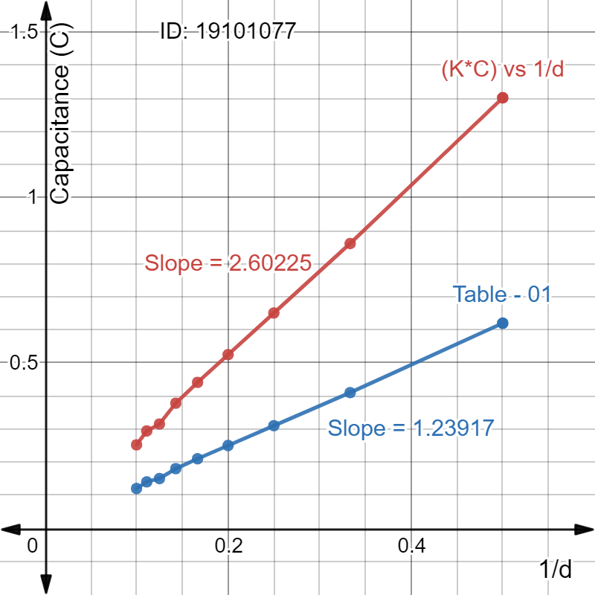

If we place a dielectric material like Teflon (κ=2.1) which dielectric constant, κ>1 in place of air with κ = 1, the values of capacitance increase. For each value of ‘1/d’ value of C increase by C = κ * C. If we use Teflon which value of κ=2.1, the value of C will be C = 2.1 * C. After placing new C in graph the of new graph become 2.60225 where Table-01 slope is 1.23917.